Review of Plums Growing in the Chase Orchard in 2023
to assist you in selecting varieties to grow in 2024

Notes:  Plums in this review are being compared with other plums ripening in the same time frame.  (J) refers to Japanese plum type (also referred to as Asian plums in some listings) and (E) refers to European plum type.  Why I grow plums. What I really like are apricots and peaches, but they are exceptionally hard to grow in the area of Eastern Washington where I live. There are two main problems with peaches and apricots. First, their one-year wood (where the fruit buds are located) is often damaged by winter weather. Since the annual crop bears on one-year wood, a hard winter can limit the number of blooms and subsequent fruit yield. The other problem is that apricots and peaches are among the first to bloom each spring and they can be hit with a late April frost that diminishes or even destroys the crop. So, although I really like apricots and peaches I rejoice in having certain excellent European plums because I can get a nice crop most years. | 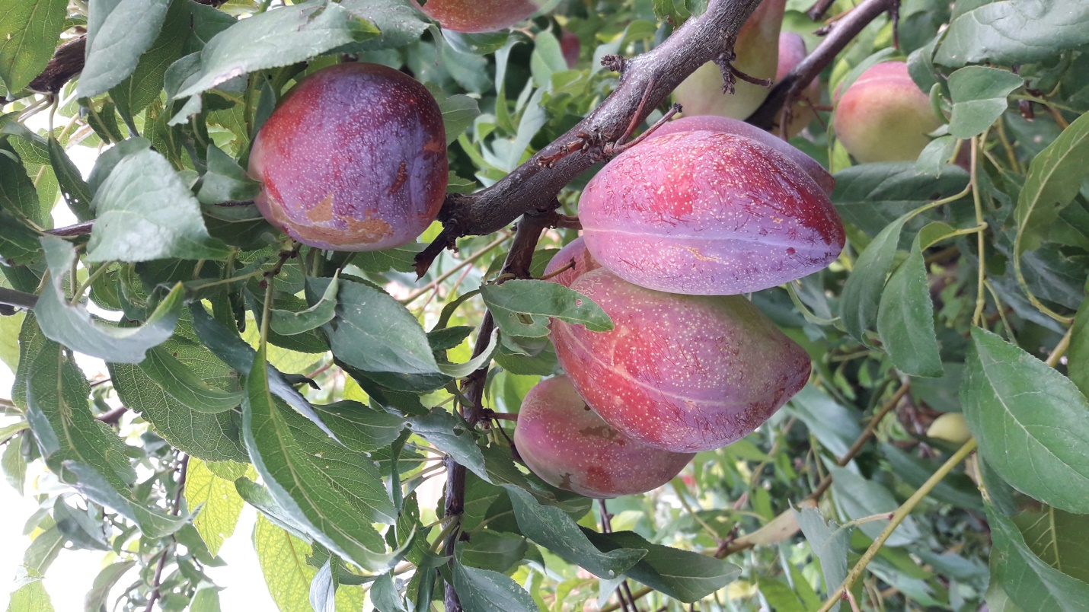
 | Luisa plum in late August .
Plums that ripen in July and August Plums
Beauty (J) – ok, but not impressive
De Montfort (E) – very good (might be in top 5).
Duarte (J) – very good (might be in top 5).
Early Golden (J) – very earliest, but not impressive (but ok because no others are ripe yet).
Early Laxton (E) – also very early, but less impressive than Early Golden.
Elma’s Special (also known as Sanctus Hubertus) (E) – outstanding (in top 5).
Honey Star (J) – impressively sweet and juicy – beautiful yellow skin.
Imperial Epineuse (E) – outstanding (in top 3)
Luisa (J) – outstanding (in top 3) Just starting to ripen in late August and continues to ripe through most of September. They keep very well in refrigeration and can last into mid October. My #1 Japanese variety. If you can grow Japanese plums where you live this is a “must have” variety for the home orchard. A picture of this plum is featured on the first page of this review.
Methley (E) – second earliest and hangs for over a month (among better of very early plums).
Monsieur Hatif (E) - outstanding (in top 3) It is a must have. I picked about 2 dozen of these in late August to refrigerate and ate them on November 8th. They had shrunk some and were almost jellied, but with good texture and flavor. They were great after over 2 months of refrigeration. They are a free-stone and can be dried easily.
Obilnaja (J) – pretty good (might be in top 5 of Japanese plums).
Opal (E) - excellent, on par with Monsieur Hatif (top tier for August – in top three).
Oullins (E)– outstanding (in top 5 and maybe in the top 3 for an early plum) It is a must have. They refrigerate well
Parsons (E) -- very early and hangs well.
Pipestone (J) – ok, but not impressive.
P. Domestica Rootstock – (may not be true name - a wild plum that forms a thicket from root succors that looks European vs. P. Americana or Japanese - seem almost identical to Parsons (probably the origin of Parsons).
Black Ice (J) – among the best Japanese plums.
Santa Rosa (J) – ok, but not impressive.
Satsuma (J) – ok, but not impressive.
Shiro (J )– ok, but not impressive other than appearance (they are a very beautiful yellow and very productive in comparison to other Japanese plums).
Toka (J) – ok, but not impressive (but does have a unique flavor for a Japanese plum).
Plums that ripen in September (rankings are against only plums ripening in September)
Bavey’s Gage (or Bavey’s Green Gage) (E) – Superior strain of the Green Gage. In my top 5 for ripening in September. Keeps well in refrigerator (they were still in nice condition on November 8th).
Castleton (E) – I would place this in my top 5 even though I think I have more than 5 in my top 5 for September.
Gras Romanesc (E) – absolutely great flavor, but so far has been a sparse bearer (although I have seen pictures of branches loaded with Gras Romansec in nursery descriptions) – definitely in top 3 for September ripening. Might be my #1 for September if I had to rank order them, instead of just voting them into the top 3 grouping or the top 5 grouping.
Green Gage (E) - excellent, but Bavey’s Gage may be a better strain of the classic Green Gage. However, after storing in the refrigerator until November 8th it was hard to tell the difference and maybe after 6 weeks of refrigeration they may have actually been a little better than Bavey’s Gage.
Kirk’s Blue (E) – Italian-style plum. Among my top 5 for September.
Luisa (J) – was in top 3 for August and because it ripens over time (not all at once) it is still producing outstanding fruit through to the 20th of September. So it is in my top 3 for September as well. And it Is in top 3 overall (for the entire season). Does not hang well, but if you check it daily you will be rewarded with some wonderful ripe plums that have just fallen on a bed of straw under the tree. Large, flavorful, freestone. Very highly regarded in New Zealand (where it originates from) in Australia.
Mirabelle de Nancy (E) – Mirabelles are those little tiny plums that are kind of a novelty (although they have good flavor and sweetness). I enjoy a few but plan to keep the tree small, just to have a few of these little novelty plums to sample each year.
Mt. Royal (E) – very productive, good dried, excellent flavor. In my top 5 for September ripening. Refrigerates will. Dries well.
Rosey Gage (E)– great flavor and sweetness, but sparse producer. In my top 5 for a September plum.
Stanley (E)- very good early version of Italian plum (and better tasting). Extremely productive. Suppose to be good drying plum. It refrigerates well and was excellent at the November 8th tasting session. Could be in my top 5.
Superior (J) – kind of a scruffy bush-like tree, poor producer, but with pretty good fruit for a Japanese plum (skin doesn’t seem to have that tart aftertaste found in many Japanese plums).
Victory (E) - has to be in top 3 for September (comes on the very last week of September). Huge plum with huge crops every year. Great flavor. Tends to ripen over a span of time and hangs well. It should be able to make it in refrigeration all the way to Thanksgiving (was excellent at the November 8th tasting session). Is a freestone and I serve it in halves like I do the Luisa, another freestone.
Yakima (E) – very large plum with great flavor. In my top 5 for September.
Plums that ripen in October and early November (rankings are only against plums ripening in October or November)
Coe’s Golden Drop (E) – large beautiful yellow plum ripens very late in October here. In my top 5 for October.
Empress (E) – very large and very productive, but seems somewhat bland (although highly regarded in reviews).
Italian(E) – Although widely grown and appreciated, I’m not a fan of Italian because there are other Italian-style plums that surpass it (but it is kind of the index of flavor comparisons for other European plums). Dries and cans well.
Moyer (E) - among best of the Italian-style plums. Better flavor and sweetness than the Italian. In my top 5 for October.
President (E) - very large and very late (end of October, first of November) with excellent flavor and sweetness. In the top 3 for October-November. Will easily store in the refrigerator until Thanksgiving.
Prune d’Agen (also known at the Petite French Prune) (E) – in my top 5 for October. Although slightly smaller than the Italian, they are sweeter and more flavorful.
Shropshire Damson (E) – highly regarded tart plum for making plum jam and chutney (very productive).
Sugar (E) – pretty good - you get better flavor and sweetness if you thin heavily.
Valor (E) – very good – refrigerates well.
Vision (E) – very good – refrigerates well.
Note on when to refrigerate: I
It seems best to pick in their prime (the whole idea of “tree ripened” is that you don’t pick it until it is ripe) if you are going to refrigerate them. If you pick them before they are ripe they don’t ripen under refrigeration. Refrigeration allows you to spread the enjoyment of a particular plum out over a much longer period of time.
Drying:
Most of the European plums are free stone with dense flesh, so they dry well without the pits. A few of the Japanese plums that are free stone can also be dried.
Philosophy of selecting plum varieties:
Because there are plums that ripen all the way from late July to early November, it seems reasonable to try to have varieties that ripen throughout the long plum season. If I could only have 6 plums I would pick two from each of the seasons (early, mid, and late). Which two? That is hard – I would probably change that to three for each of the season seasons. You can never have too many plums.
Criteria for evaluation:
Faint praise – when I say a plum is “pretty good for a Japanese plum” I am usually comparing it to other Japanese plums. If I were to pick my top 20 plums, probably only 3 out of the 20 would be Japanese plums. The first 17 would all be European except for Luisa, a Japanese plum, which would be in the top 3. So #19 and #20 would be the other two Japanese plums in the top 20.
Almost all Japanese plums are sweet and juicy, but many have a tart aftertaste in their skin. Some are bland. European plums usually have complex flavors (vs. being merely sweet and juicy). To be fair, there are also some bland European plums too, but there are so many flavorful Europeans over the span of the summer and fall that is easy to come up with a top 20 plum list composed almost entirely of European plums.
Rootstocks for Plums:
St Julian A:
- precocious, productive, and cold hardy
- controls at 7 to 10 feet high for pedestrian orchard (no ladders)
- can also be used for apricots and peaches
- compatible with plums, most apricots, and most peaches (very versatile as a rootstock for stone fruit

Krymsk 1 (also known as VVA1):
- precocious, productive, and cold hardy
- controls at 6 to 10 feet high for pedestrian orchard (no ladders)
- compatible with most plums, but not peaches (except for Red Haven)
- compatible with only a few apricots

Marianna GF8-1 and Marianna 2624
- not as suckering as Myrobalan
- good vigor but probably a little more size controlling than Myrobalan
- very widely used plum rootstock for both European and Japanese types

Myrobalan
- Some uckering observed (sometimes a lot)
- good vigor (will need more pruning than St. Julian A or Krymsk 1)
- most widely used plum rootstock for both European and Japanese types
- produced from both seed and cloning (Myro 29C)

Krymsk 86
- gives you a vigorous tree about the size of Marianna and Myrobalan
- excellent anchorage
- very adaptable to various soil types and resistant to many diseases affecting stone fruit rootstock
- should have less tendency to sucker than for Marianna or Myrobalan
- compatible with most plums, many peaches, some apricots, and all almonds

Prunus Americana (American wild plum)
- used with Japanese plums and interspecifics
- expect some suckers

Prunus Domestica (wild plum from Europe)
- used for European plums
- expect a lot of suckers

Peach
- compatible with plum, apricot, almond, and peach
- may not be as hardy and long lived as some of the other choices above

St. Julian A and Krymsk 1 are my first choice (more precocious) for plums and could be planted with 8 foot spacing if you choose. Marianna and Myro are also good and will require 10 to 12 foot spacing.

Establishing A Plum Orchard – My Recommendations
If you want to build out a 10-variety plum orchard that spans the early plum season, mid plum season and late plum season consider these:
Early Season: Methley, Oullins
Mid Season: Luisa, Victory, Monsieur Hatif, Imperial Epineuse, Opel
Late Season: President, Coe’s Golden Drop, Moyer
If you have the space, consider adding Mount Royal, Elma’s Choice, Casteleton, Bavey’s Gage, Gras Romanesc.

If you get the above varieties on either St. Julian A or Krymsk 1 rootstock they will come into production a little faster (those rootstock induce precociousness) and be a little easier to maintain at a 7 or 8 foot height.

