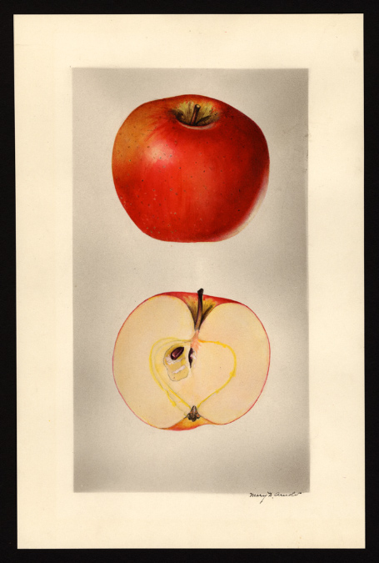
Arkansas Beauty (see picture above)
The book, Old Southern Apples notes that the Arkansas Beauty was extinct and that it was introduced in 1886. Stark Bros’ Nursery carried the apple in their catalogs in the early 1900’s.
The apple was described in The Apples of New York, vol 1:
“The Arkansas Beauty is of Arkansas origin. It is above medium in size. The flesh slightly tinged with yellow, … moderately crisp, tender, juicy, mild subacid, taste is good.”
This apple actually colors better in eastern Washington than its native Arkansas. The apple was rediscovered in 2016 in Whitman County, WA.

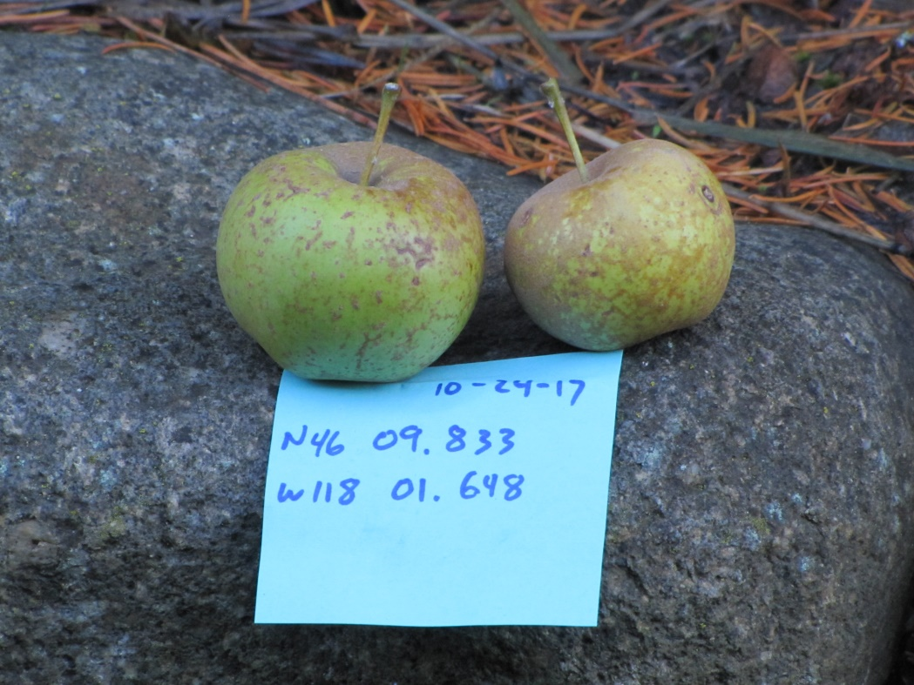

Autumn Grey (see picture above)
First recorded in 1869. A small, yellow apples, nearly covered with thin nettings of russet. Tender, rich, aromatic, very good for dessert. (also known as Autumn Pomme Gris) This apple was re-discovered near Waitsburg, WA, in 2017.

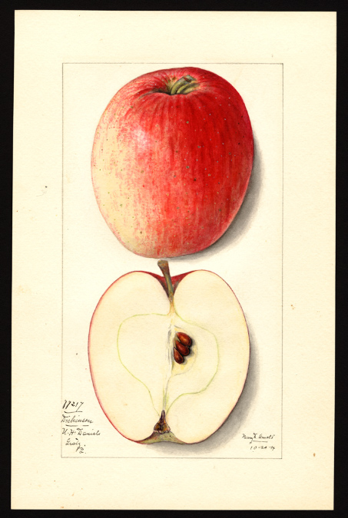
Dickinson (see picture above)
Below is a description from The Apples of New York, vol 2:
…Very productive. Fruit resembles Yellow Bellflower in shape, but the color is red. It is of good size and attractive enough in appearance to make a good market apple, but it is not above second rate in quality.
Historical. Grown from seed of the Yellow Bellflower by Sarah Dickinson, Westchester, Pennsylvania……..
Fruit medium to large, somewhat variable in size. Form oblong-conic…Skin smooth, light yellow or green, blushed and mottled with bright red, striped with darker red, sprinkled with inconspicuous, small green and whitish dots. Prevailing effect red with well-colored fruit…
Flesh yellowish, juicy to very juicy, moderately fine-grained, slightly aromatic, subacid, moderately firm, tender, fair to good. Season November to April. Known as a good keeper. This apple was re-discovered in Whitman County, WA, in 2016.
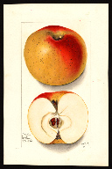
Ewalt (see picture above)
The Ewalt originated at the farm of John Ewalt near Bradford, Pennsylvania, sometime before 1800. The apple is described as a large yellow apple with a crimson flush. The flesh is described as firm, juicy, with good to very good quality. A good keeper apple, the Ewalt can last in storage until April or longer. This apple was re-discovered near Hauser Lake, ID, in 2017.

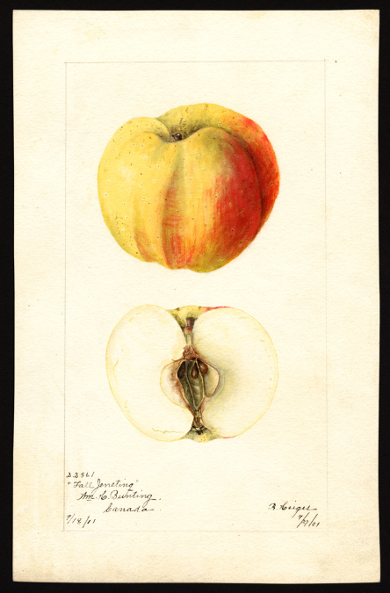
Fall Jeneting (see picture above)
One of the most unusually shaped apples ever. The tree produces beautiful orange, red, and yellow apples that have distinct ridges. The apple was popular at one time and is described in a variety of books and pamphlets from the 1800’s into the early 1900’s.

The book “The Apples of New York”, by S.A.Beach, volume 2, 1903, describes the Fall Jenetting as “very good for culinary uses and acceptable for dessert; is not a good keeper.”

The twenty-fifth annual report of the Fruit Growers Association of Ontario (Canada) sessional papers (37) 1894, stated that the Fall Jeneting “is a variety that cannot possibly be beaten in the way of canning apples.”

The apple is stunning in appearance, good tasting, but as a fall apple, ripening before the end of September, will not last in your refrigerator as long as winter varieties.

This apple was re-discovered in Maine in 2013. A second Fall Jeneting was found in Whitman County, WA, in 2014.

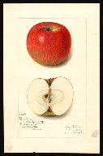
Flushing Spitzenburg (see picture above)
Named by William Prince of Prince Nursery in Flushing, N.Y. prior to 1820. Medium to large in size, with deep orange-red skin. The flesh is white; juicy and sweet, sometimes stained red, ripe in October. Considered extinct when it was re-discovered near Hauser Lake, ID, in 2017.

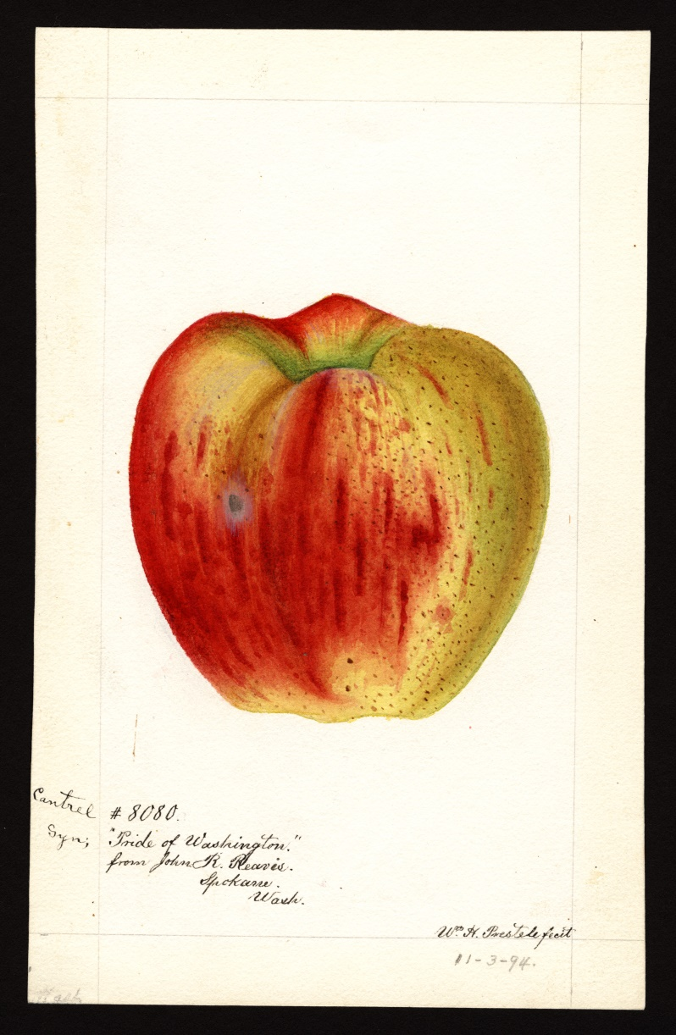
Frazier’s Prolific, aka Cantrel or Pride of Washington
Cantrell (Cantrel) Frazier planted one of the first commercial orchards in Walla Walla County. Walla Walla historian W. D. Lyman wrote about Frazier in 1918, saying one of his seedlings grew into a mammoth tree that was reputed to be the largest in the state - more than 7 feet, 7 inches in circumference around the base with a spread of 57 feet and height of 42 feet. Frazier and his tree gained fame when it yielded a crop of over 126 boxes of apples in 1907. The tree was commonly called Frazier’s prolific apple tree. Although the original tree died in the 1980’s it was cloned shortly before perishing. A clone was planted near Fort Walla Walla Mueum and still produces big crops of apples.

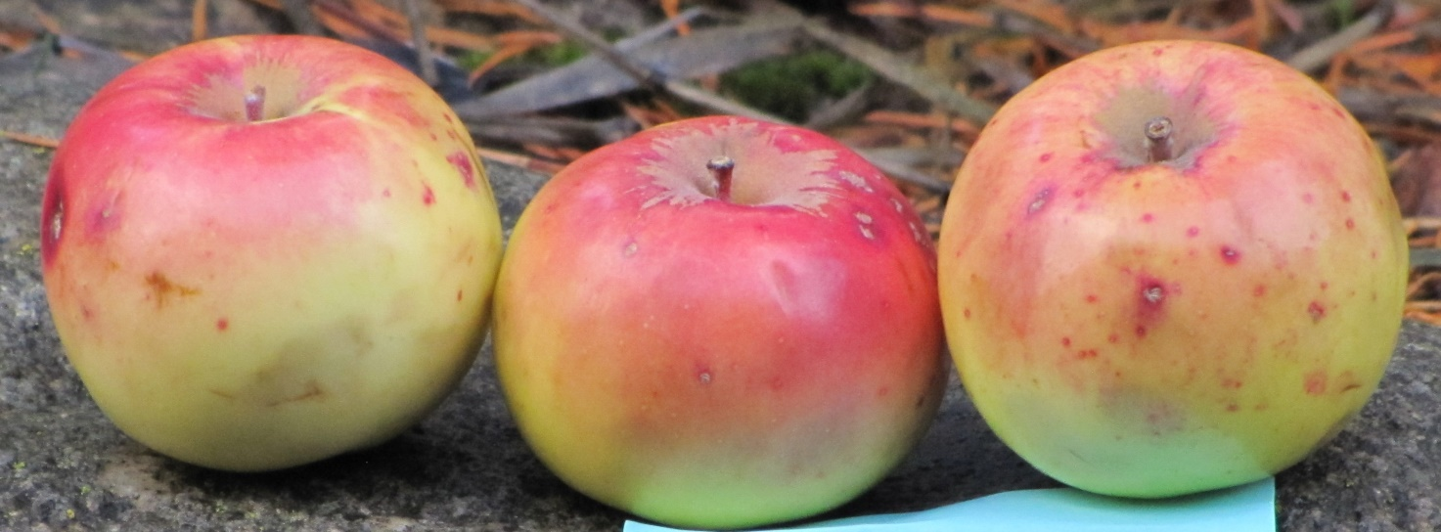
Kittageskee (see picture above)
Probably originated with the Cherokee Indians in North Carolina, introduced in 1851. It was sent to France by P. J. Berckmans Nursery, Augusta, Georgia, in 1860. It was sold in Europe until at least 1905. The apple has yellow skin flushed with bronze. It is small to medium in size, the flesh is nearly sweet and aromatic. A very good winter apple. Considered extinct when it was re-discovered near Boise, ID, in 2017.

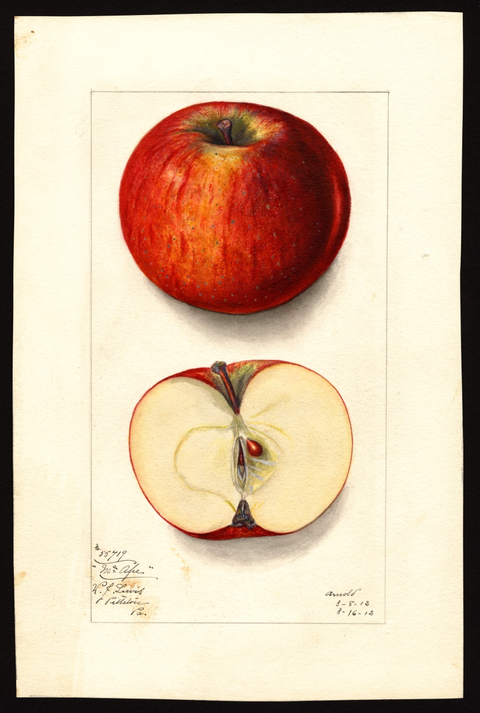

McAfee’s Nonsuch see picture above)
McAfee’s Nonsuch has been known by many names. Dan Bussey tells of a seedling sown in 1773 at McAfee’s Station near Harrodsburg, Kentucky. The McAfee family came to Kentucky from Virginia and built along the Salt River where they planted an orchard. He described this apple as: “Medium to large in size, roundish oblate conic. Skin rather thin, yellowish green splashed and striped red flushing to crimson, often marked with thin, grayish, mottled or streaked scarf skin and sometimes with fine, irregular broken russet lines.” Considered extinct when it was re-discovered in Whitman County, WA, in 2017.

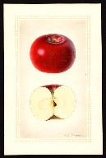
Nero (see picture above)
Originated on a farm in New Jersey in 1879. Popular apple in New York in the early 1900’s. Medium to above medium in size. Roundish and bright red. Flesh crisp, juicy, subacid with sweet taste. Late in season.
Considered extinct when it was re-discovered in Whitman County, WA, in 2015.

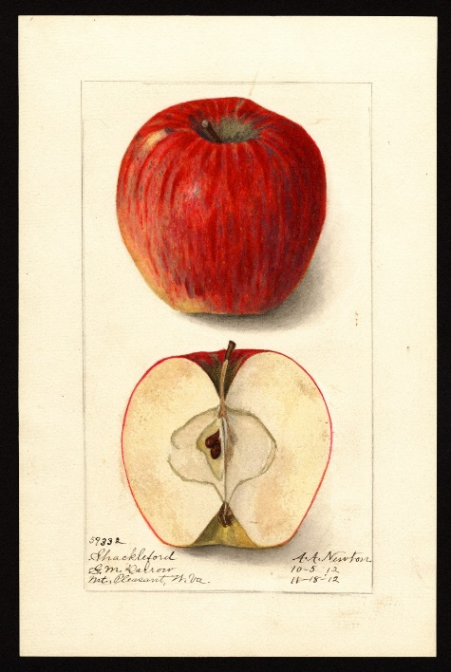
Shackleford (see picture above)
Apple expert Lee Calhoun wrote that the Shackleford is “medium to large, roundish or roundish oblong; skin thick, tough, waxy, smooth, pale-greenish yellow washed with red and mottled and striped with carmine….crisp, juicy, mild sub-acid. Ripe December – May. In a nursery catalog from 1912, the Shackleford was described as “large, well colored, purplish red in the sun, with a delicate bloom; mild sub-acid, aromatic. Considered extinct when it was re-discovered in Whitman County, WA, in 2017. Apple researcher David Benscoter considers the Shackleford one of the best tasting of the recent re-discoveries.
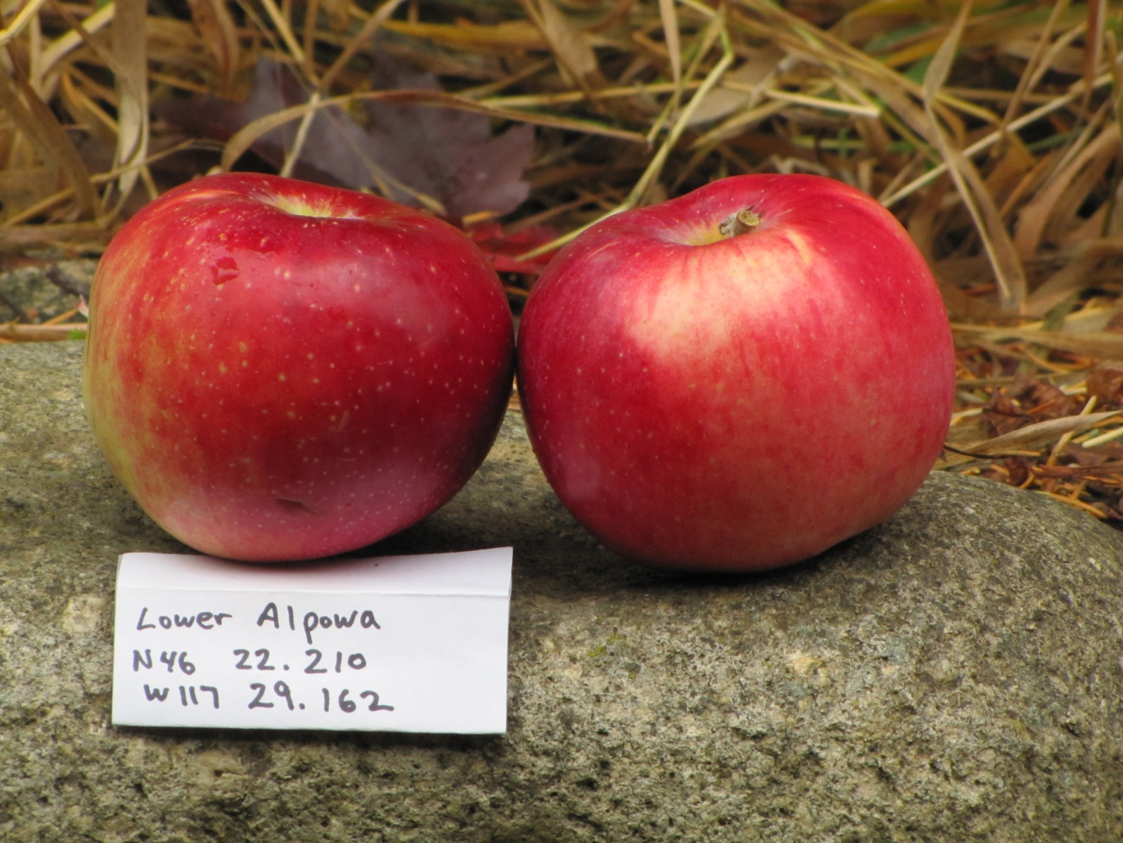
Constantine (see picture above)
Constantine is a Russian apple that was known before 1873. It is a large, roundish, with crimson streaks over greenish yellow skin. The apple ripens in late September to November and its flavor is described as fair to good for kitchen use. The apple was found at the site of an old orchard near Alpowa Creek, about mid-way between Clarkston and Pomeroy, WA.

Surprise (a.k.a. Blood)

Surprise, also known as the Blood Apple, is believed to have originated in Colorado around 1898. Bussey describes this apple as roundish and medium in size. The skin is brownish yellow with faint patches of slight red coloring under the skin. The most striking characteristic about the apple is its deep pinkish-red flesh.

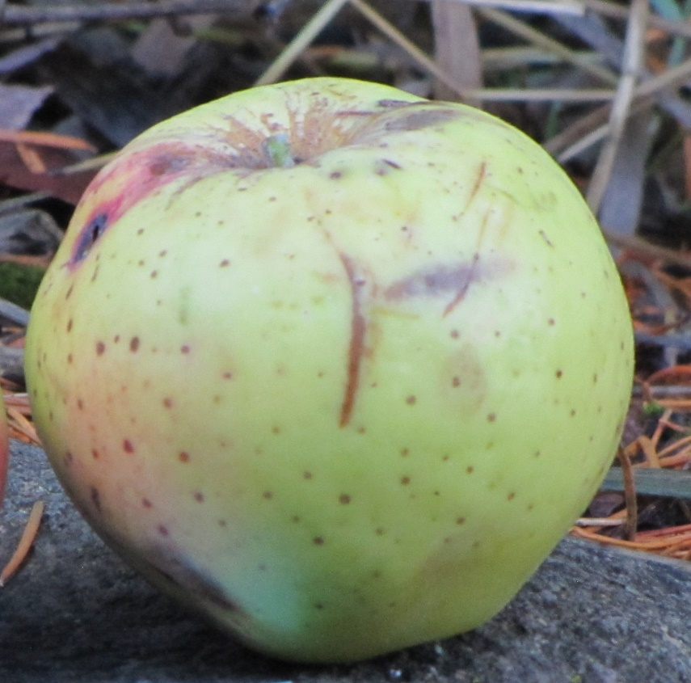
Jackson Winter Sweet (see picture above)
The Jackson Winter Sweet is believed to have originated in Pennsylvania sometime in the early 1900’s. Yellowish-green in color, the apple is described as a sweet apple with a near honey-like sweetness. When used as a sweet apple, it is good to very good in quality. Bussey quoted one source that described the apple “though not very attractive in appearance, it would seem very much worthwhile as a sweet apple for home use. The apple was found in an old orchard near Waitsburg, WA.

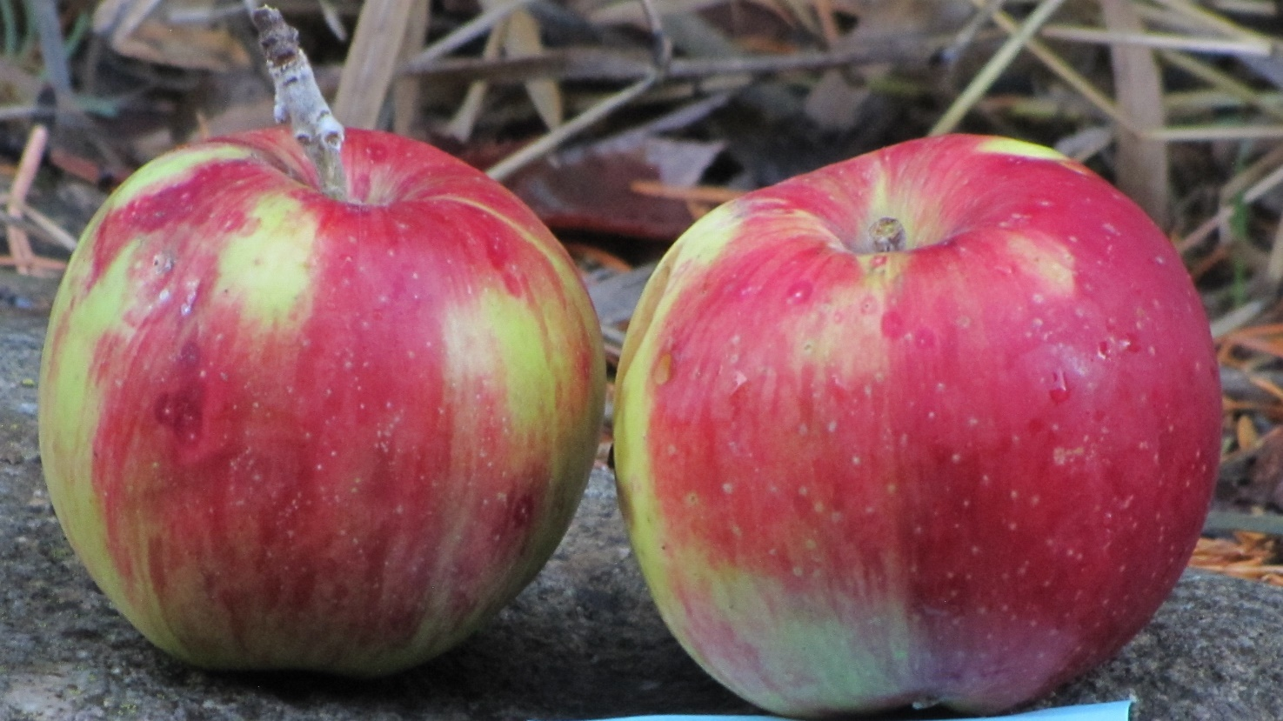
Streaked Pippin (see picture above)
The Streaked Pippin was first recorded in 1869 in New York but may date back to 1744. It is a large apple, pale yellow or greenish covered by an orange-red blush and distinct deep red stripes. The flavor, as described in apple books, is good to very good. The tree was found at the site of an old homestead near Waitsburg, WA.

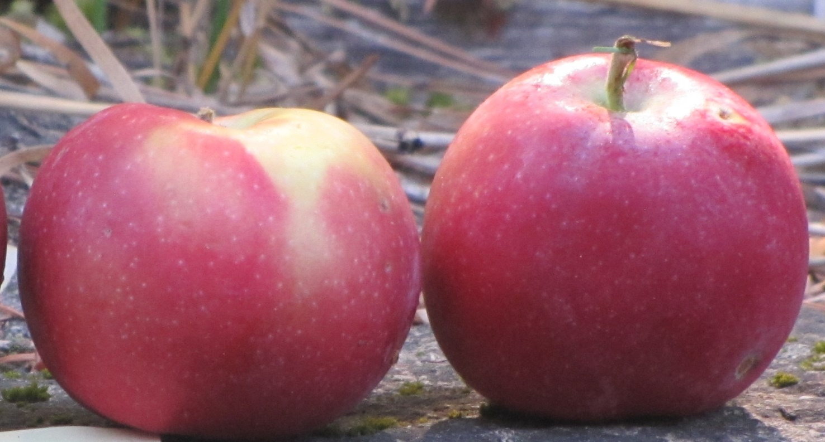
Excelsior
A small red apple from inside the city limits of Moscow, ID, turned out to be a very special apple. The Excelsior was first recorded in 1879 and is a red apple with flavor described as good to very good. The apple has an extraordinary history. The apple was bred (not found as a seedling as most heritage apples are) by the first man to breed apples in the United States, Peter Gideon. Gideon’s first and most successful apple was the Wealthy apple. The Wealthy, and later the Excelsior and a few other apples developed by Gideon, were the first apples to be successfully grown commercially in in Minnesota due to the state’s harsh winter temperatures. The Wealthy was developed in the 1860’s and the Excelsior followed years later. In 2004, author James Curran wrote about Gideon in his book, The Great American Apple Wizard. Curran wrote that the 15 varieties Gideon introduced after the Wealthy were eventually lost and “the Wealthy alone survives. It is Peter Gideon’s monument.” Today, another monument to Gideon has been found growing in Latah County, Idaho.

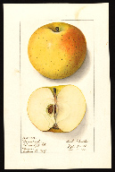
Regmalard (see picture above)
The Regmalard, also known as Reinette de Regmalard, was known to have been grown in New York, New Jersey, and Pennsylvania in the late 1800’s and in Illinois and New York in the early 20th century. The apple is large, yellow, with a small blush of red. It ripens late and is considered a good keeper. A watercolor of the apple was painted in 1912 by the US Department of Agriculture and is available to view on its website. LAP volunteer E.J. Brandt found this apple growing in a forgotten orchard near the town of Troy, ID.

